Barry Anthony Sprunger
April 10, 1944 – December 16, 1981

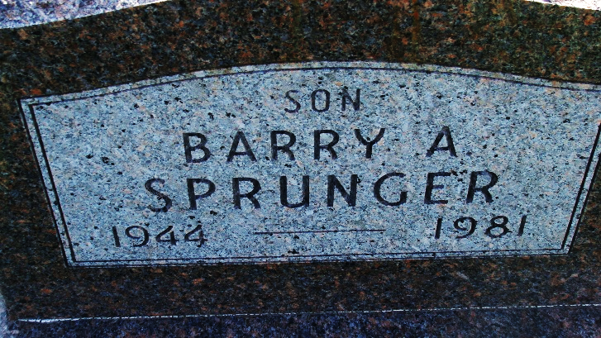
Photo by Alica Kneuss

Indiana, U.S., Birth Certificates, 1907-1944

Name Barry Anthony Sprunger
Gender Male
Birth Date 10 Apr 1944
Birth Place Fort Wayne, Allen, Indiana, USA
Father Willard F. Sprunger, age 35y
Mother Betty Lou Mentzer age 22y 2 of 2 children living
Registration Year 1944
Certificate Number 17441
Roll number 60871.IDX.002_I1415173
Volume Range 31-35
**

Florida, U.S., Death Index, 1877-1998

Name Barry Sprunger
Race White
Age at Death 37
Birth Date 10 Apr 1944
Death Date 16 Dec 1981
Death Place Monroe, Florida, United States

