Barbara J. (Lehman) Sprunger
September 16, 1833 – August 3, 1874
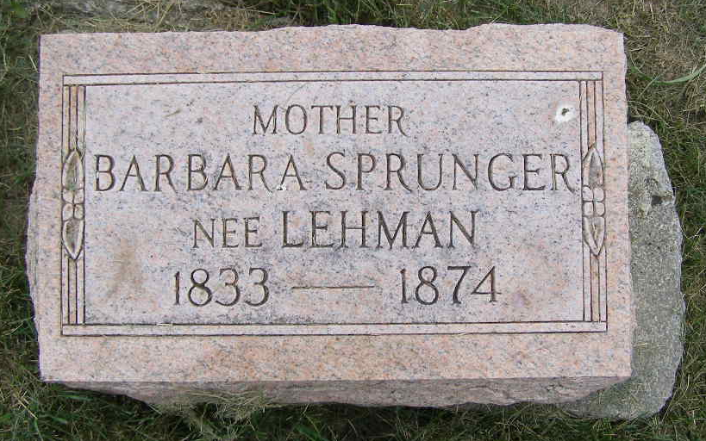
Photo by Shaunda Bedwell Opdycke

Web: Indiana, U.S., Deaths, Pre-1882

Name Barbara Sprunger
Maiden Name Lehman
Gender Female
Death Date 3 Aug 1874
Death Place Adams, Indiana, USA
URL http://www.genealogycenter.info/search_pre1882deaths.php
**

U.S., Family History Books

Name Barbara Lehman
Gender Female
Marriage Date 1 Jan 1859
Marriage Place Wayne County, Ohio
Death Date 3 Aug 1874
Father John Lehman
Spouse David Sprunger
Child Elisabeth, Anna, Judith, Lila, Ester, Delia, Elisabeth, Josua, Isaak, Rosia, P. Lilemon, Judith, Amos, Anna, Carolina. Barbara, Maria, Emil, Adell, Naomi, Caleb
Title The Sprunger Family, 1757-1972: in Three Parts From Manuscripts
p. 24
#5. David Sprunger, born July 5, 1836 on the Latin Dachzfeldenberg, Switzerland, married January 1, 1859 Barbara Lehman, daughter of John Lehman, Wayne County, Ohio. They lived near Berne, Indiana. Barbara died August 3, 1874, then on August 3, 1876 David married secondly to Regina Moser, daughter of Christian Moser. David was a Bauer (farmer) and a fork-maker.
11 children listed.

