Barbara Ann Sprunger
October 17, 1926 – September 23, 2018
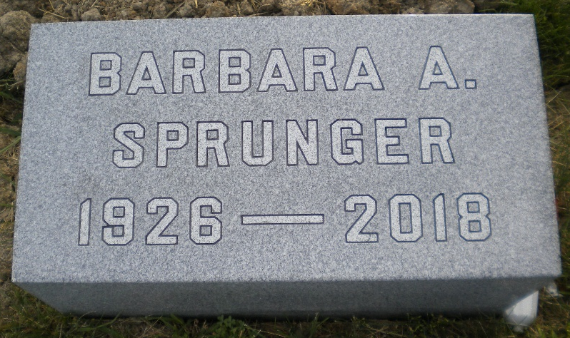
Photo by DSON1492

Barbara Ann Sprunger, age 91, passed away on Sunday, September 23, 2018 at Swiss Village, where she was a resident. She was born on October 17, 1926 in Fort Wayne, Indiana, to Clifton “Wifty” Sprunger and Naomi Haecker Sprunger
Barbara was a faithful member of First Mennonite Church of Berne. She received her Bachelor’s degree in Education from Bluffton University, and her Masters degree in Education from Indiana University. She was a long time 6th, 5th and 3rd grade teacher, having taught at Monroe, Berne-French and South Adams Schools. Hundreds of her former students knew her fondly as “Miss Barbara.”
Preceding her in death are her parents and brother, James Sprunger.
Visitation will be two hours prior to the memorial service at 11:00 a.m. on Saturday, September 29, 2018, at Swiss Village auditorium. Burial will be in the MRE Cemetery, Berne.
Preferred memorials may be given to Swiss Village Samaritan Fund or Mennonite Central Committee.

Zwick & Jahn Funeral Home, Adams County, Indiana

