B. Helen (Long) Sprunger
January 21, 1901 – May 21, 1979

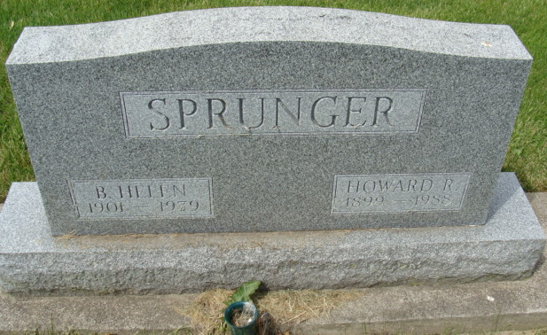
Photo by Alicia Kneuss

Indiana, U.S., Death Certificates, 1899-2017

Name B. Helen Sprunger
[B. Helen Long]
Gender Female
Race White
Marital Status Married
Age 78
Birth Date 21 Jan 1901
Birth Place Indiana
Death Date 21 May 1979
Death Place Berne, Adams, Indiana, USA
Death Registration Date 1979
Father William Long
Mother Lulu Choler
Spouse Howard Sprunger, informant
Burial MRE Cemetery 5/23/1979

