B. Franklin Sprunger
September 18, 1895 – September 2, 1983

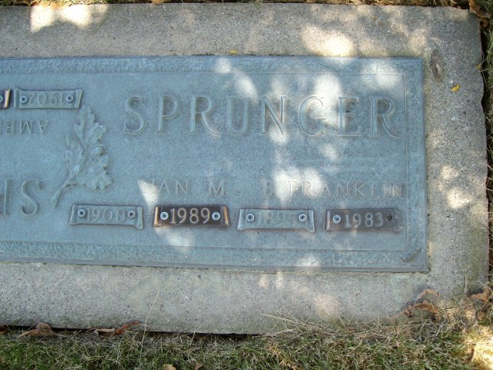
Photo by smalltown

B. Franklin Sprunger, 87, a resident of Swiss Village, Berne, IN, died at 12:51 pm Friday, Sept. 2 in the Adams County Memorial Hospital. Death was attributed to complications and followed an illness of several years. Sprunger was a retired finishing foreman at Dunbar Furniture and a member of First Mennonite Church in Berne. He was a lifetime resident of Adams County.
He was born in Berne on Sept. 18, 1895, the son of C. C. and Rosina (Reusser) Sprunger. On April 20, 1917 he married Nan Eckrote and she survives.
Also surviving are three sons, Roger Lee Sprunger, Berne; Jethro B. Sprunger, Decatur; and Donald F. Sprunger, Pinellas Park, FL; 2 daughters, Mrs. Richard B. (Gretchen) Lehman, of Pandora, Ohio and Mrs. Merlin (Delores) Habegger of Palatine, IL; 2 brothers, Victor P. Sprunger, Waterford, MI and Paul Sprunger of Milwaukee, WI; 16 grandchildren and 27 great-grandchildren. One son, Rev. Derryl Sprunger, three sisters and three brothers preceded in death.
Funeral services were held at 3 pm. Monday, Sept. 5 in the First Mennonite Church with Rev. Kenneth W. Bauman officiating and burial followed in the M.R.E. Cemetery.
Preferred memorials are the Church Missions or Swiss Village.
Yager Funeral Home of Berne was in charge of the arrangements.

Unknown source
Wednesday, Sep 7, 1983
**

Indiana, U.S., Death Certificates, 1899-2017

Name B. Franklin Sprunger
Gender Male
Race White
Marital Status Married
Age 87
Birth Date 18 Sep 1895
Birth Place Indiana
Death Date 2 Sep 1983
Death Place Decatur, Adams, Indiana, USA
Death Registration Date 1983
Father C. C. Sprunger
Mother Rosina Reusser
Spouse Nan (Eckrote) Sprunger
Informant Roger Lee Sprunger, son
Burial M.R.E. 9/5/1983

