Audrey E. ‘Dollie’ (Chronister) Sprunger
August 3, 1915 – January 24, 2000

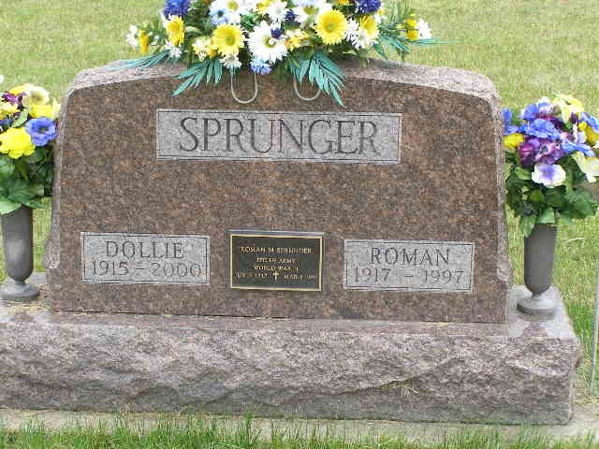
Photo by Shaunda Bedwell Opdycke

Audrey E. "Dollie" Sprunger, 84, of Decatur, a member of American Legion Auxiliary, died Monday, Jan. 24, 2000, at Adams County Memorial Hospital. The Bobo native was a homemaker, and a member of Mount Zion United Brethren in Christ Church in Bobo and its Women's Missionary Society. Surviving are sons Richard W. and Edward A. Sprunger, both of Decatur; a daughter, Ann L. Miller of Decatur; a sister, Marjorie Lenwell of Fort Wayne; a brother, Kenneth Chronister of Tucson, Ariz.; seven grandchildren; and three great-grandchildren. She was preceded in death by her first husband, Charles Schlandenhauffen, and her second husband, Roman Sprunger. Services are 10 a.m. Friday at Zwick & Jahn Funeral Home, Decatur, with calling from 1 to 8 p.m. Thursday. Burial will be at M.R.E. Cemetery, Berne. Memorials are to the church. Information provided by Zwick & Jahn Funeral Home, Decatur, 1-219-724-9164.

News-Sentinel, The (Allen County, Indiana)
Wednesday, January 26, 2000

