Arthur F. Sprunger
April 5, 1905 - August 15, 1976
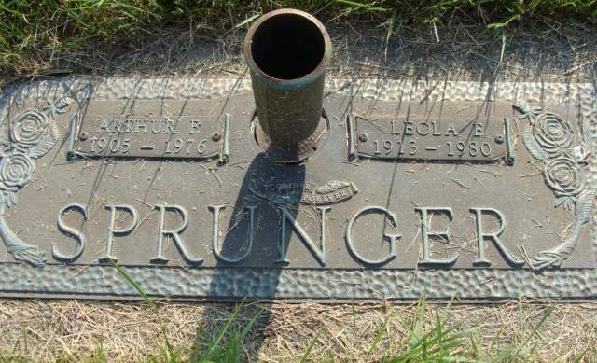
Photo by Alicia Kneuss

Arthur F. Sprunger, 71, affectionately known as Skeezix, Route 1, Berne died at 8:30 a.m. Sunday at the Clinic Hospital in Bluffton. Death was attributed to cancer and came after a comparatively short illness.
He was hospitalized two weeks. First admitted to the ???, he was transferred from ??? to an Indianapolis hospital, then returned to Bluffton a day before he died. Sprunger was a retired employee of Central Soya Company where he was in maintenance.
He was born in Monroe Township, Adams County the son of Alfred and Robertine Liechty-Sprunger. He was married to Leola Simon, May 23, 1941 at the E.U.B Parsonage in Berne.
Surviving are the wife, a son, Duane Sprunger, Route 1, Berne; a daughter, Mrs. Richard (Suzanne) ?? Route 1, Monroeville; two brothers, Ervin ?? Sprunger and Vernon L. Sprunger, both of Berne and six sisters, Mrs. Palmer (Florence) Moser, Mrs. Milton (Goldie) Liechty, Mrs. Curtis (Gertrude) Wulliman, Mrs. Fr??? (Ruth) Sprunger, Mrs. Dale (Anna) Rich and Mrs. Denver (Vernelle) Yoder, all of the Berne community, and five grandchildren. A son, in infancy and the parents preceded in death.
Mr. Sprunger was a member of the First Mennonite Church. Services will be held in the chapel of the church at 10 a.m. Wednesday, Rev. Kenneth Bauman officiating. Burial will be in the M.R.E. Cemetery.
The body is at the Yager Funeral Home where friends may call after 7 p.m. today. The body will lie in state at the church Wednesday from 9 a.m. to the time of the service. Preferred memorials are for missions.

Burial Plot: SW ¼ 8-Sec.1-5th ADD
Date of Death: August 15, 1976; Date of Burial: August 18, 1976
Berne (IN) Library Heritage Room
1973-1984 MRE Obit Book, image #122

