Arminda (Hirschy) Sprunger
February 9, 1901 – November 20, 1964
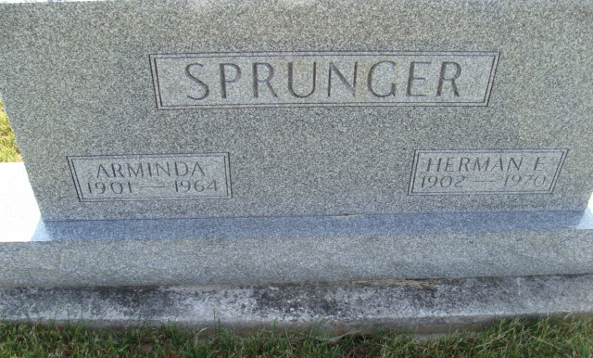
Photo by Alicia Kneuss

Berne - Wabash Township resident, Mrs. Arminda Sprunger, 63, died unexpectedly at 8:30 pm Friday at her home. The husband, Herman E.; five sons, two daughters, six grandchildren, four sisters, and a brother, Clarence Hirschy, Fort Wayne, survive. The body is at the Yager Funeral Home.

Journal-Gazette, Allen County, Indiana
Saturday, November 21, 1964, Page 2A
**

Indiana, U.S., Death Certificates, 1899-2011
Name: Arminda Sprunger
[Arminda Hirschy]
Gender: Female
Race: White
Age: 63
Marital status: Married
Birth Date: 9 Feb 1909 [sic]
Birth Place: Indiana
Death Date: 20 Nov 1964
Death Place: Berne, Adams, Indiana, USA
Father: C P Hirschy
Mother: Louisa Felber
Informant: Herman E Sprunger; husband; Berne, Indiana
Burial: November 23, 1964; MRE Cemetery; Berne, Indiana

