Arley Sprunger
June 28, 1901 – January 10, 1980
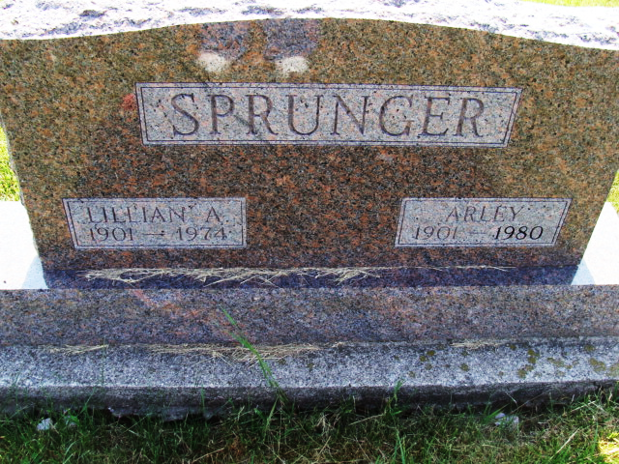
Photo by Alicia Kneuss

Arley Sprunger
in the Indiana, U.S., Death Certificates, 1899-2011
Name: Arley Sprunger
Gender: Male
Race: White
Age: 78
Marital status: Widowed
Birth Date: 28 Jun 1901
Birth Place: Indiana
Death Date: 10 Jan 1980
Death Place: Berne, Indiana, USA
Father: Emmanuel Sprunger
Mother: Katherine Stauffer
Informant: Mrs. Loren Sprunger; Fort Wayne, Indiana
Burial: January 12, 1980; MRE Cemetery; Berne, Indiana

