Annette Sue (Berlien) Sprunger
May 6, 1938 – February 23, 2025
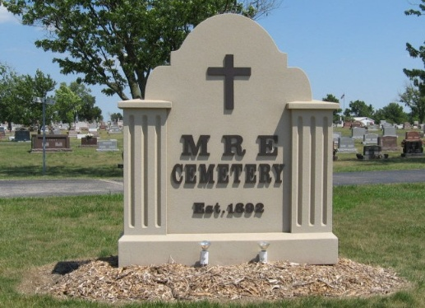
Photo by Tombstoner & Family

Annette “Sue” Sprunger, 86, of Bluffton, Ohio passed into the loving arms of her Savior, Jesus, Sunday, Feb. 23, 2025. She was born May 6, 1938, in Fort Wayne to Paul and Opal (Wasson) Berlien. She was married Aug. 26, 1961, to Ben Sprunger.
A woman of deep faith, she dedicated her life to her family, church and community. She was a faithful wife, loyal helper and mother with distinction.
Her career in education spanned many years, serving at the Worthington School Board office and as a secretary at Worthington Estates Elementary and Worthington Hills Elementary, where she became a beloved mother and grandmother figure to countless children.
While living in Bluffton, Ohio, she was a passionate community leader, cofounding the Reaching Women Conference and helping establish the Bluffton Community Daycare. As the wife of President Ben Sprunger, she embraced her role with grace, welcoming students, alumni and donors with her gift of hospitality. She also loved entertaining friends in the many places she called home, creating warm and lasting connections wherever she went.
Her children and grandchildren will forever cherish her love of nature, gardening, flowers and birds as well as the special pies and countless cookies she made just for them.
She is survived by her husband of Bluffton, Ohio; daughter, Julie (Dave) Stratton of Bluffton, Ohio; two sons, Jon (Jacki) Sprunger of Delaware, Ohio; and Benjamin P. Sprunger of Atlanta, Georgia; five grandchildren, Amanda (Axel) Erickson; Sarah (Christian) Koch; Noah (Taylor) Stratton; Jakob (Alli) Sprunger; Joe Sprunger; four great-grandchildren; and sister-in-law, Cyril Berlien of Fort Wayne.
Sue was preceded in death by her parents; brother, Bruce Berlien; and son-in-law, Erik Burns.
Visitation will be Wednesday, Feb. 26 from 4-7 p.m. at Chiles-Laman Funeral & Cremation Services, 239 S. Main St., Bluffton, Ohio and Saturday, March 8 for one hour prior to the 11 a.m. celebration of life service at First Mennonite Church in Berne. Burial will be at MRE Cemetery in Berne.
Memorials may be made to Global Disciples or Sarasota Community Church, Sarasota, Florida.
Arrangements provided by Chiles-Laman Funeral & Cremation Services in Bluffton, Ohio. Online condolences may be made at www.chiles-lamanfh.com.

The Berne Witness, Adams County, Indiana
February 26, 2025

