Anna Verena (Luginbill) Sprunger
January 27, 1903 – September 29, 1988
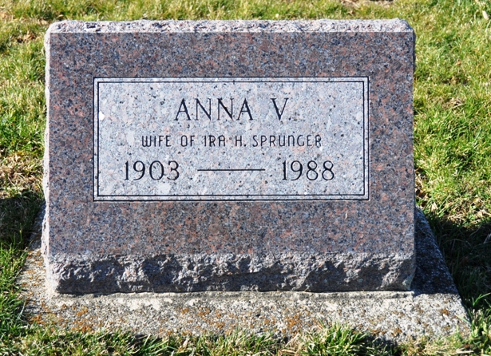
Photo by Deb Curry

Anna V Sprunger
in the Indiana, U.S., Death Certificates, 1899-2011
Name: Anna V Sprunger
[Anna V Luginbill]
Gender: Female
Race: White
Age: 85
Marital status: Widowed
Birth Date: 27 Jan 1903
Birth Place: Adams County Indiana
Death Date: 29 Sep 1988
Death Place: Berne, Adams, Indiana, USA
Father: Eli Luginbill
Mother: Ella Neuenschwander
Informant: Ardythe Flueckiger; daughter; Berne, Indiana
Burial: October 1, 1988; MRE Cemetery; Berne, Indiana

