Anna (Sprunger) Sprunger
April 6, 1840 - April 4, 1864

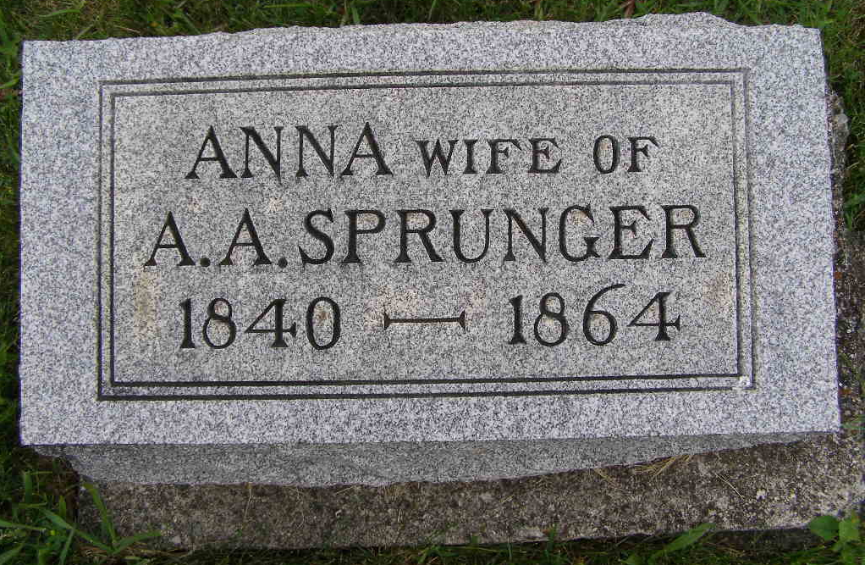
Photo by Shaunda Bedwell Opdycke

Anna Sprunger from tree Julie Frederick Family Tree

Birth 6 Apr 1840 Moutier, Bern, Switzerland
Marriage 22 Nov 1862 Adams, Berkshire, Massachusetts, USA
Residence 1870 Monroe City, Adams, Indiana, USA
Death 4 Apr 1864 Berne, Adams, Indiana, USA
Father Abraham Sprunger (1797-1889)
Mother Anna Barbara Moser (1798-1843)
Spouse Abraham A. Sprunger (1841-1906)
14095 People 6 Records 32 Sources
**

Indiana, Marriage Collection, 1800-1941

Name Anna Springer
Marriage Date 22 Nov 1862
Marriage Place Adams, Indiana, USA
Spouse Name Abraham Springer
**

U.S., Family History Books

Name Anna Sprunger
Gender Female
Marriage Date 22 Nov 1862
Marriage Place Adams County, Indiana
Death Date 4 Apr 1864
Father Abraham Sprunger
Spouse Abraham A Sprunger
Child Maria Moser, Samuel, Enna
Title The Sprunger Family, 1757-1972: in Three Parts From Manuscripts
p. 33
#10 Abraham A. Sprunger born February 22, 1841 on the Corgemontberg, Switzerland, married November 22, 1862 to (6) Anna Sprunger, daughter of Abraham Sprunger, in Adams County, Indiana. Anna died April 4, 1864.
Children by first wife Anna Sprunger: Levi born November 1, 1863

