Anna S. L. Sprunger
January 5, 1870 – May 23, 1911
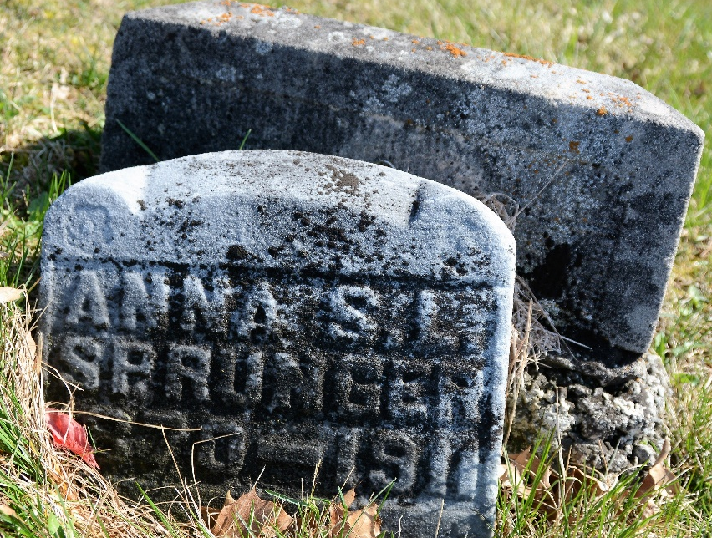
Photo by Deb Curry

MISS ANNA SPRUNGER
Tuesday forenoon occurred the death of Miss Anna Sprunger, daughter of widow Anna Sprunger, living on West Franklin street. She had not been well for some time but had only been bedfast since Saturday, death resulting from pneumonia.
Anna Sprunger was born January 5, 1870, on a farm northeast of Berne, and lived here all her life. Almost two years ago she moved to town with her mother. She was a faithful member and attendant of the Mennonite church.
The bereaved are her aged mother; five sisters, Maria, Mrs. Martha Welty, Mrs. Miriam Steiner, Mrs. Ida Amstutz and Miss Selma; five brothers, Silas, Jacob, Nathan, Enoch and Cornelius and a host of other relatives. Two sisters preceded her in death.
The funeral will be held this forenoon at 8:30 o'clock at the house and 9 o'clock at the church.

Berne Witness, Adams County, Indiana
Friday, May 26, 1911

