Anna R. Sprunger
June 20, 1876 – June 19, 1954
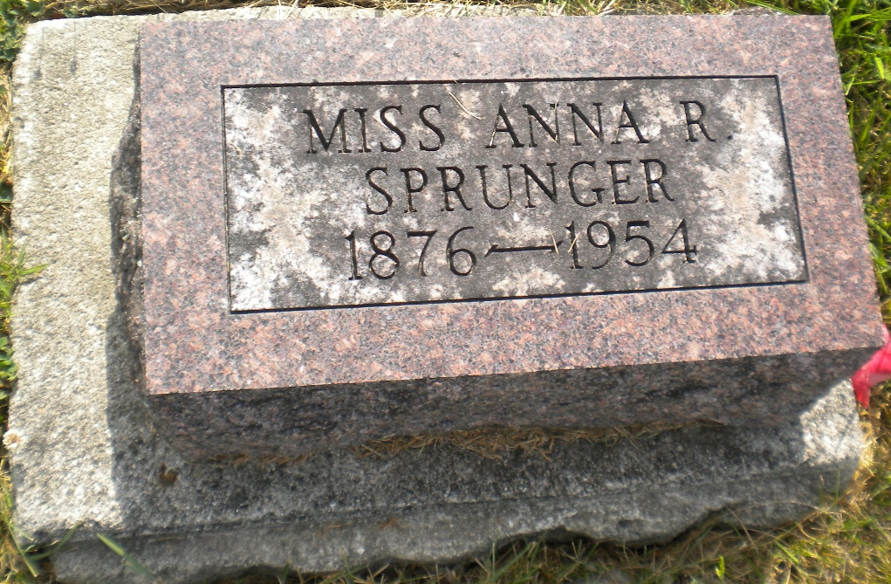
Photo by DSON1492

Anna R Sprunger
in the Indiana, U.S., Death Certificates, 1899-2011
Name: Anna R Sprunger
Gender: Female
Race: White
Age: 78
Marital status: Never Married (Single)
Birth Date: 20 Jun 1876
Birth Place: Bern, Switzerland
Death Date: 19 Jun 1954
Death Place: Berne, Adams, Indiana, USA
Father: Peter Sprunger
Mother: Anna Reusser
Informant: Rev. J. J. Klopfenstein; Berne, Indiana
Burial: June 21, 1954; MRE Cemetery; Berne, Indiana

