Anna (Liechty) Sprunger
December 25, 1861 – March 4, 1945

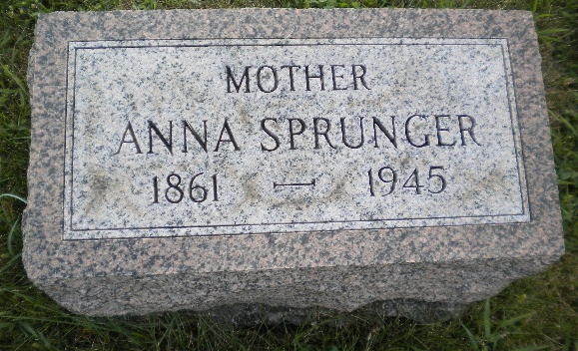
Photo by DSON1492

DEATH TAKES MRS. ULRICH SPRUNGER SUNDAY NIGHT
Local Lady Dies on Anniversary of Husband's Death; Funeral Wed.
Mrs. Anna Liechty Sprunger, 83, widow of the late Ulrich Sprunger, passed away last night at 11:05 o'clock at her home on West Franklin Street, following an illness that extended through the past three months. Death was caused by a heart ailment and dropsy. She had been failing since December 5 and was bedfast for a number of weeks. She sank into a coma Saturday and did not regain consciousness.
By a strange coincidence she passed away on the anniversary and at the same hour of the death of her husband, which occurred on March 4, 1932.
Mrs. Sprunger was a native of Wayne County, Ohio, the daughter of Mr. and Mrs. Jacob Liechty, and was born on Christmas day in 1861, bringing her age to 83 years, two months and nine days. She came to this community at the age of three months when her family moved here. Her marriage to Mr. Sprunger occurred on October 28, 1885 in the Mennonite church here. The couple resided on their farm north of town, until they retired to their home on West Franklin Street, a few years before Mr. Sprunger passed away. The farm on which they resided is now owned and occupied by their son, Joel, and family.
Surviving are the following children: Dora, at home; Oscar of this place; Joel on the home farm; Eldon and Marcus of this place, and Frieda at home. A son, Walter, at the age of 30, and a son and daughter in infancy, preceded her.
She was the last surviving member of her parental family, six brothers and a sister having preceded her. They were Samuel, Emanuel, Chris, Jacob, Peter, Joel and Mrs. David Lehman.
The deceased was a lifelong member of the First Mennonite Church here, where funeral services will be held on Wednesday afternoon at 2 o'clock, with Rev. John P. Suderman officiating. Burial will be in the MRE Cemetery. The body was returned to the home this afternoon from the Yager mortuary.
Berne Witness, Adams County, Indiana
Monday, March 5, 1945

