Anna (Liechty) Sprunger
January 20, 1854 – April 24, 1939

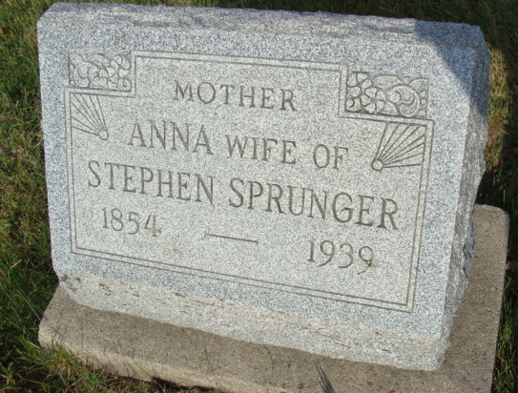
Photo by Alicia Kneuss
Handwritten date: Monday, April 24, 1939
85-Year-Old Local Woman Expires Today
Mrs. Anna Sprunger Dies
Funeral Wednesday at Mennonite Church

Mrs. Anna Sprunger, aged 85, widow of the late Stephen Sprunger, died at 3 o'clock this morning at her home on Van Buren Street. Death came after a long illness of old age and complications. She had been ailing since January and was bedfast the past two weeks.
Mrs. Sprunger was one of the best known women of this community. The deceased was born at Chippewa, Ohio, January 20, 1854, a daughter of Christian and Katherine Lehman Liechty. She was married to Stephen Sprunger on Oct. 31, 18?4. They lived in this community during most of their married life and Mrs. Sprunger resided in Berne for the last 27 years.
Surviving are the following children: Mrs. Helena Baderstscher, Pandora, Ohio; Mrs. Katherine Baderstrscher, Bluffton, Ohio; Jonathan Sprunger, Fort Wayne; Ezra Sprunger, Indianapolis; Miss Adina Sprunger, Berne; Miss Zilla Sprunger, Outwood, Kentucky; Tobias Sprunger, Fort Wayne; Hiram Sprunger who lives at the David F. Lehman home in ​Monroe Township, and Miss Elda Sprunger of Berne. Three sisters survive, Mrs. Katie Beer and Mrs. John Winteregg, both of Berne and Mrs. Cleophas Neuenschwander, Pandora, Ohio.
A half brother and two half-sisters survive; Noah Liechty, Mrs. Adam Bixler and Mrs. John Schumacher, all of Pandora, Ohio. Nine grandchildren and two great-grandchildren also survive.
The husband, the parents, a daughter, Mrs. Ruth Gerber, a son and daughter in infancy and a half- brother proceeded.
The body will be taken to the home late today from the Yager Funeral Home here and may be viewed after 7 o'clock this evening. Mrs. Sprunger was a member of the Mennonite Church and the funeral will be held Wednesday afternoon at 1:45 o'clock at the home and at 2 o'clock at the church, Dr. C. H. Suckau officiating. Burial will be in the M.R.E. Cemetery.
Adams County (IN) Historical Society
1939 Scrapbook, Image 068-069
**
Indiana, U.S., Death Certificates, 1899-2011
Name: Anna Sprunger
[Anna Piecktly]
Gender: Female
Race: White
Age: 85
Marital status: Widowed
Birth Date: 20 Jan 1854
Death Date: 24 Apr 1939
Death Place: Monroe, Whitley, Indiana, USA
Father: Christian Liechty
Mother: Katherine Lehman
Spouse: Stephen Springer
Informant: Miss Elda Sprunger, Berne, Indiana
Burial: April 26, 1939; MRE Cemetery

