Anna (Lehman) Sprunger
May 31, 1859 – January 12, 1927

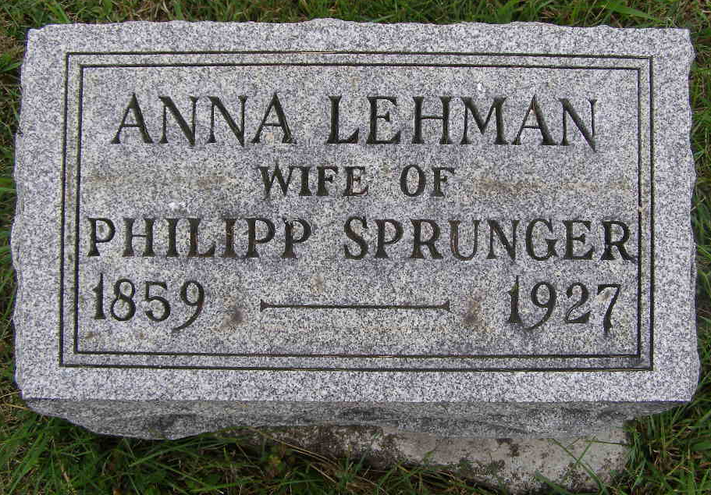
Photo by Shaunda Bedwell Opdycke

Anna Spunge
in the Indiana, U.S., Death Certificates, 1899-2011
Name: Anna Sprunger
[Anna Lehman]
Gender: Female
Race: White
Age: 67
Marital status: Married
Birth Date: 31 May 1859
Birth Place: Indiana
Death Date: 12 Jan 1927
Death Place: Berne, Adams, Indiana, USA
Father: Christian Lehman
Mother: Anna Sprunger
Spouse: Philip Sprunger
Informant: Philip Sprunger; Berne, Indiana
Burial: January 14, 1927; MRE Cemetery

