Anna J. (Sprunger) Sprunger
September 27, 1843 – March 31, 1918
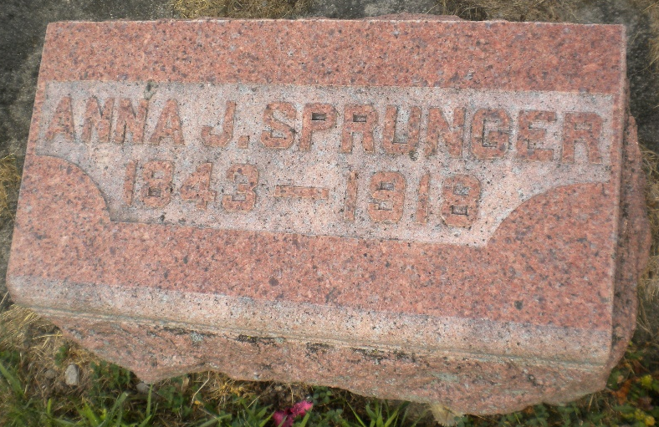
Photo by DSON1492

Mrs Anna J. Sprunger
in the Indiana, U.S., Death Certificates, 1899-2011
Name: Mrs Anna J. Sprunger
Gender: Female
Race: White
Age: 74
Marital status: Widowed
Birth Date: 27 Sep 1843
Birth Place: Switzerland
Death Date: 31 Mar 1918
Death Place: Wayne, Allen, Indiana, USA
Father: Peter C Sprunger
Mother: Barbara Zurcher
Informant: Anna Sprunger; Fort Wayne, Indiana
Burial; April 3, 1918; MRE Cemetery

