Anna E. (Lehman) Sprunger
October 28, 1913 – July 3, 2016
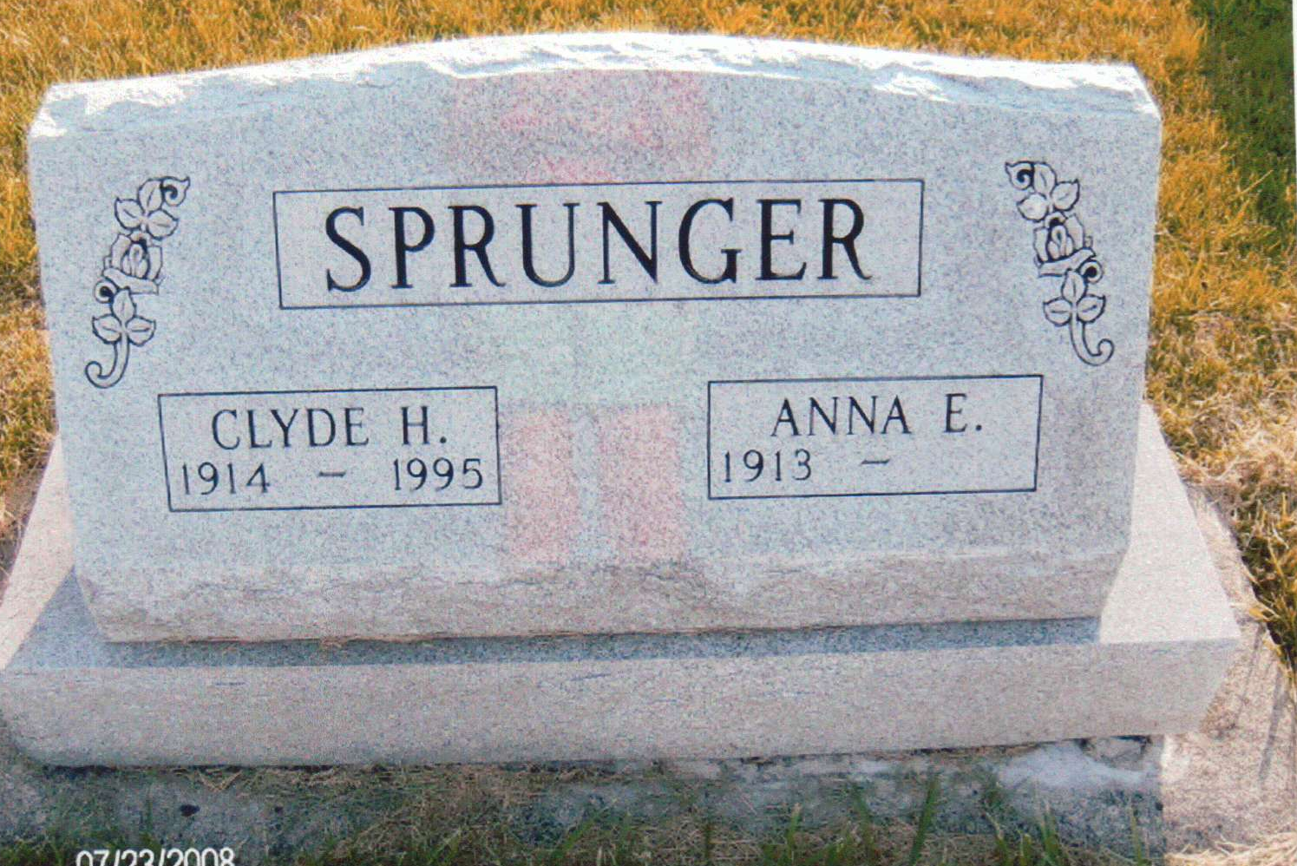
Photo by JC

Anna E. Sprunger, 102, Berne passed away Sunday morning, July 3, 2016 at Swiss Village where she was a resident since January, 1992. She was born to Edwin and Bertha Soldner Lehman on October 28, 1913 in Adams County, IN. She married Clyde Sprunger on October 22, 1938 in Berne.
Anna was a faithful member of the First Missionary Church where she sang in the choir. She was a registered nurse having graduated from the Fort Wayne Lutheran School of Nursing in 1935. She was employed with Dr. Beaver for a number of years, Adams Memorial Hospital, and did private practice. She loved music and was a member of the Berne Swiss Chorus group which performed in the area and at many Berne Swiss Days.
Survivors include many nephews and nieces. Preceding in death are her parents, brother Eloyd Lehman, sisters, Loretta McLaughlin, Nova Gerber and husband, Clyde ('95).
Funeral services are Monday, July 11, 2016 at 2:00 pm at Swiss Village Chapel with visitation 1 hour prior to the service. Officiating is Pastor Anita Rediger. Burial is in the MRE Cemetery. Preferred memorials are to Swiss Village Samaritan Fund.

Yager-Kirchhofer Funeral Home, Adams County, Indiana
July 7, 2016

