Anna C. Sprunger
August 1, 1911 – October 22, 1968
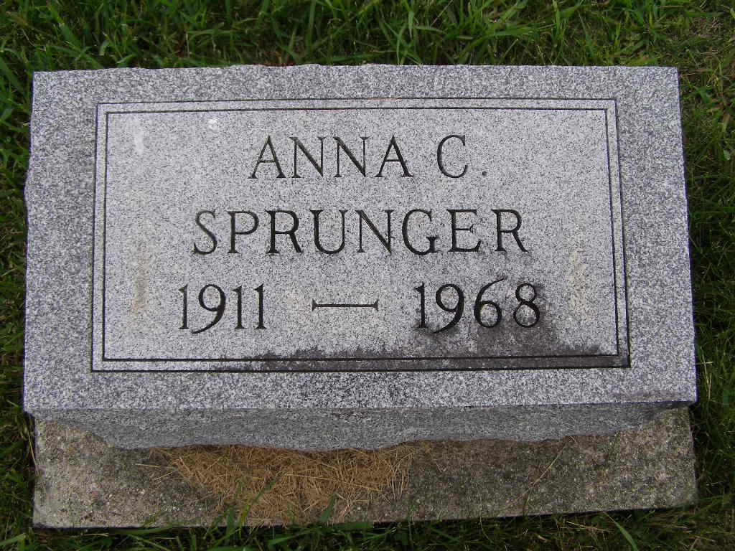
Photo by Shaunda Bedwell Opdycke

Miss Anna C. Sprunger, 57, Dies Tuesday
Services Thursday for Widely Known Local Woman
Miss Anna C. Sprunger, 57, 712 West Wabash Street, died at 1:55 am Tuesday at the Adams County Memorial Hospital following an illness of six days. Death was attributed to a massive cerebral hemorrhage which she suffered in her home.
Miss Sprunger was semi-retired. For 30 years, she was employed as a secretary for Moser Motor Sales. For many years, she managed a catering service, specializing in wedding receptions and became widely known throughout the community. She was a lifelong resident of Berne.
A native of Berne, Miss Sprunger was born August 11, 1911, a daughter of Levi A. and Mathilda Baumgartner Sprunger.
Surviving are two sisters, Mrs. E. J. (Alina) Neuenschwander of Berne and Mrs. Harry D. (Lydia) McCreery, Battle Creek, Michigan. Two brothers, Grover and Harry Sprunger and a sister, Mrs. Leona Liechty, preceded in death.
Miss Sprunger was a member of the First Mennonite Church where services will be held at 1:30 pm Thursday. Rev. Gordon Neuenschwander will officiate and burial will be in the MRE Cemetery. Friends may call at the Yager Funeral Home.

Date of Burial: October 24, 1968; Burial: MRE
Berne (IN) Public Library Heritage Room
1967-1971 MRE Obit Scrapbook
**
Indiana, U.S., Death Certificates, 1899-2011
Name: Anna C Sprunger
Gender: Female
Race: White
Age: 57
Marital status: Never Married (Single)
Birth Date: 1 Aug 1911
Birth Place: Indiana
Death Date: 22 Oct 1968
Death Place: Decatur, Adams, Indiana, USA
Father: Levi A Sprunger
Mother: Mathilda Baumgartner
Informant: Rev. Gordon Neuenschwander; nephew; Berne, Indiana
Burial: October 24, 1968; MRE Cemetery; Berne, Indiana

