Anna Barbara (Lehman) Sprunger
December 19, 1794 – November 18, 1877
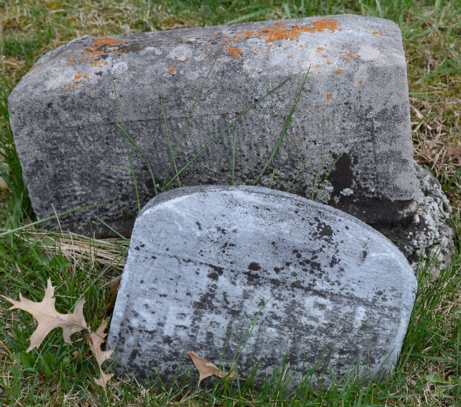
Photo by Deb Curry

Anna Barbara Lehman Sprunger from tree Sprunger Family Tree

Birth 19 Dec 1794 Moutier, Bern, Switzerland
Marriage 4 Nov 1848 Thurgau, Switzerland
Residence 1870 Adams, Indiana, USA
Death 18 Nov 1877 Berne, Adams, Indiana, USA
Father JOHANN HANS LEHMAN (1764-1846)
Mother Barbara Marie Leemann (1764-1831)
Spouse Johannes J. Sprunger (1793-1853)
17991 People 24 Records 42 Sources
**

U.S., Family History Books

Name Barbara Lehman
Gender Female
Marriage Date 4 Mar 1816
Death Date 18 Nov 1877
Father Johann Lehman
Spouse Johannes Sprunger
Title The Sprunger Family, 1757-1972: in Three Parts From Manuscripts
Author Lochner, Electa I. Baltzell (Electa Iantha Baltzell), 1895-
p. 5 2nd Generation
- Johannes Sprunger born March 10, 1793 on the Huttenberg, Canton Bern, Switzerland, married March 4, 1816 to Barbara Lehman, daughter of Johann Lehman. They lived on a Pachtgut on the Latan Dauchzfeldenberg, Canton Bern, Switzerland. Johannes was a hand work Weber or weaver. On the 6th of March was appointed a Deacon, In 1852 the family came to America, and lived in Wayne County, Ohio. He died March 1, 1853. The mother and children moved to Adams County, Indiana. The mother died November 18, 1877 in Adams County, Indiana.

