Anita M. (Kennel) Sprunger
April 12, 1933 – May 30, 2011

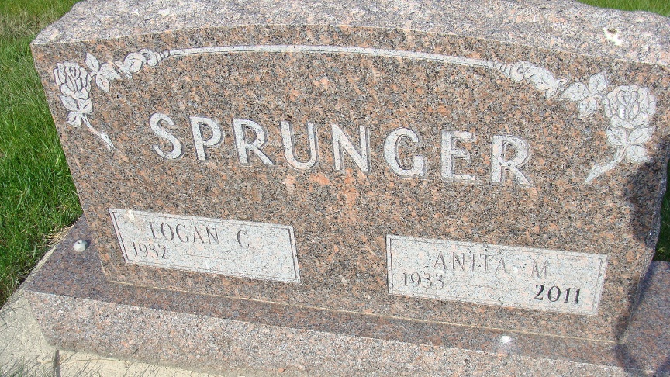
Photo by Alicia Kneuss

Anita M. Sprunger, 78, Berne, passed away May 30, 2011 at Swiss Village. Anita was born on April 12, 1933 to Alvin and Linda (Lehman) Kennel, both deceased. She married Logan Sprunger on June 9, 1951 who survives.
Anita was a member of the First Mennonite Church where she taught Sunday School, Bible School and was a leader for Christian Endeavor. She was a member of the Chancel Choir and Mennonite Choral Society. She was previously employed by Sprunger Shoes and the Young Ones. She was a former member of the Berne Mother's Club. Her special interests included: sewing, knitting, caring for her flowers, and enjoying music.
She is survived by her husband, daughters, Renee (Floyd) Liechty, Berne, Jilaine (Joe) Graber, Berne, and son, Scott (Connie) Sprunger, Berne Seven grandchildren, Jeremy (Betsy) Liechty, Amber (Jason) Huffman, Jade (Jill) Liechty, Alyssa (Tim) Hildebrand, Kristina Sprunger, Jennifer (Matthew) Gilbert, and Allison Sprunger. Ten Great grandchildren, Reid and Tanner Liechty, Chase, Will, and Ty Huffman, Grace, Isabelle, and Emme Liechty, Adia Hildebrand, and Lauren Dudgeon. Sisters, Eleanor (Howard) Flueckiger, Berne, Marilyn (Jim) Yoder, Ft. Wayne.
She is preceded in death by her parents, son, Jonathan, and brother, Howard Kennel.
Funeral services will be held Saturday, June 4, 2011 at 2:00 pm at the First Mennonite Church with visitation one hour prior to services. Officiating are Pastor Jerry Flueckiger and Marie Nussbaum. Friends will be received Friday from 2 to 8 pm at the Swiss Village Chapel. Burial will be at the MRE Cemetery.
Preferred memorials to the First Mennonite Church Assistance Fund and/or Family Hospice NE Indiana.
Zwick & Jahn Funeral Home, Adams County, Indiana
May 31, 2011

