Anita Jo Sprunger
April 9, 1954 – April 26, 1954

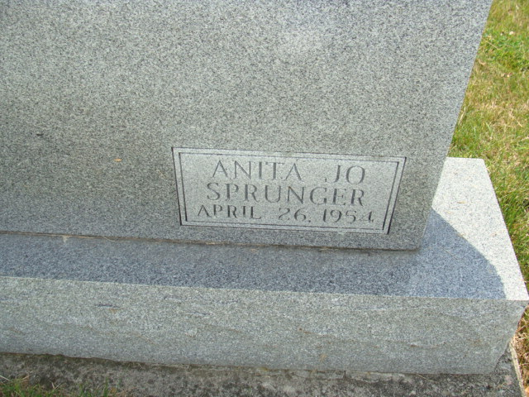
Photo by Alicia Kneuss

Indiana, U.S., Death Certificates, 1899-2017

Name Anita Jo Sprunger
Gender Female
Race White
Marital Status Never Married (Single)
Age 2 weeks
Birth Date 9 Apr 1954
Birth Place Decatur, Indiana
Death Date 26 Apr 1954
Death Place Fort Wayne, Allen, Indiana, USA
Death Registration Date 1954
Father Ornell Sprunger, informant
Mother Vivian Gottschalk
Burial M.R.E. Cemetery 4/26/1954

