Angela A. (Affolder) Sprunger
June 11, 1965 -

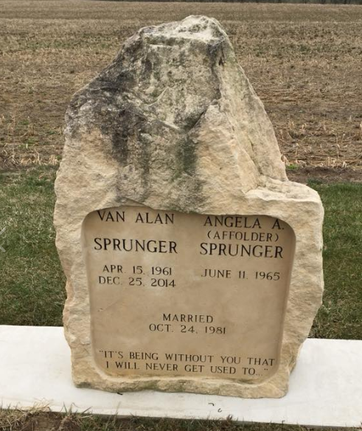
Photo by Scott Shoup

Indiana, U.S., Marriage Certificates, 1960-2012

Name Angela A Affolder
Gender Female
Marriage Age 16
Birth Date abt 1965
Birth Place Indiana
Marriage Date 24 Oct 1981
Marriage Place Bern, Adams, Indiana, USA
Marriage Registration Date 1981
Spouse Van Alan Sprunger
Description Adams-Marshall
Notes 2 N
Reference Number 1 Bx1445
Reference Number 2 Tr8538
Certificate Number 81-045587
Box Number Box 1h

