Amelia M. (Badertscher) Sprunger
August 16, 1902 – October 11, 1986

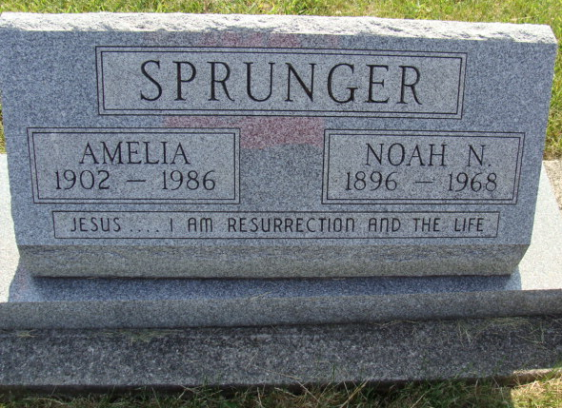
Photo by Alicia Kneuss

BERNE - Amelia Sprunger, 84, died at 4:25 p.m. Saturday in Swiss Village Retirement Center. Her husband, Noah, died in 1968. Surviving are three daughters, Kathryn, of Chicago, Helen Buckingham of Geneva, and Marjorie Gaskill of Berne; and two sons, Adrian, of Sedalia, Mo., and Stanley of Berne. Services pending through Yager-Kirchhofer Funeral Home.
Fort Wayne Journal Gazette, Allen County, Indiana
October 12, 1986
**
Indiana, U.S., Death Certificates, 1899-2011
Name: Amelia Sprunger
[Amelia Badertscher]
Gender: Female
Race: White
Age: 84
Marital status: Widowed
Birth Date: 16 Aug 1902
Birth Place: Indiana
Death Date: 11 Oct 1986
Death Place: Berne, Adams, Indiana, USA
Father: Emil Badertscher
Mother: Barbara Nussbaum
Informant: Stanley Sprunger; son; Berne, Indiana
Burial: October 15, 1986; MRE Cemetery; Berne, Indiana

