Amelia A. (Baumgartner) Sprunger
December 2, 1902 – May 21, 2002

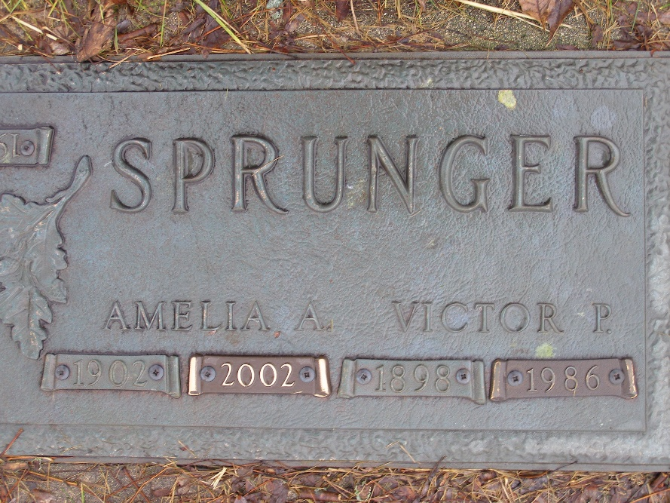
Photo by Shaunda Bedwell Opdycke

Amelia A. Sprunger, 99, of Tavares, Fla., a member of First Mennonite Church in Berne, died Tuesday, May 21, 2002, in Eustis, Fla. The Adams County native had worked at Berne Nursing Home and Palmer House Restaurant as a pie baker. She was on the original staff at Swiss Village as a nurse's aide.
Surviving are her son, Rev. Gerald E. of Weed, Calif.; a daughter, Phyllis Gehman of Tentwater, Mich., and The Villages, Fla.; 18 grandchildren and 38 great-grandchildren. She was preceded in death by her husband, Victor, a brother and five sisters.
Services are noon Friday at Yager-Kirchhofer Funeral Home, Berne, with calling two hours before services. Burial will be at MRE Cemetery. Memorials are to the church. Information provided by Yager-Kirchhofer Funeral Home, Berne, 1-260-589-3101.

News-Sentinel, The (Allen County, Indiana)
Saturday, May 25, 2002

