Amanda M. (Egly) Sprunger
June 22, 1889 – May 12, 1979

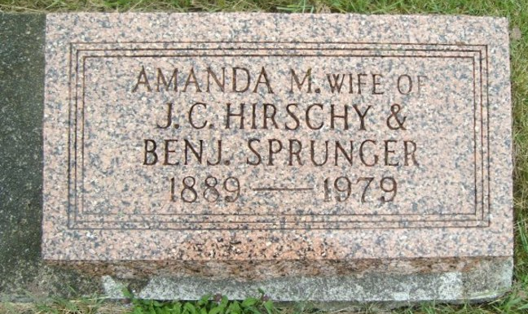
Photo by smalltown

Mrs. Amanda Sprunger, 89, of Swiss Village, Berne, died Saturday at 8:15 p.m. at the Adams County Memorial Hospital. She had been in ill health for six months. She was a member of the First Mennonite Church.
Born in Adams County on June 22, 1889, she was the daughter of Abraham and Leah Stuckey-Egly, and was married to John Hirschy. She later married Ben Sprunger and both husbands preceded her in death.
Survivors include a daughter-in-law, Mrs. Viola Moser, Berne; two grandchildren and six great-grandchildren. Five brothers preceded her in death.

Unknown source
**

Indiana, U.S., Death Certificates, 1899-2017
Name Amanda Sprunger
[Amanda Egly]
Gender Female
Race White
Marital Status Widowed
Age 89
Birth Date 22 Jun 1889
Birth Place Indiana
Death Date 12 May 1979
Death Place Decatur, Adams, Indiana, USA
Death Registration Date 1979
Father Abraham Egly
Mother Leah Stuckey
Informant Howard Baumgartner
Burial M.R.E. 5/15/1979

