Alta Fern (Raber) Sprunger
May 31, 1914 – September 18, 1997

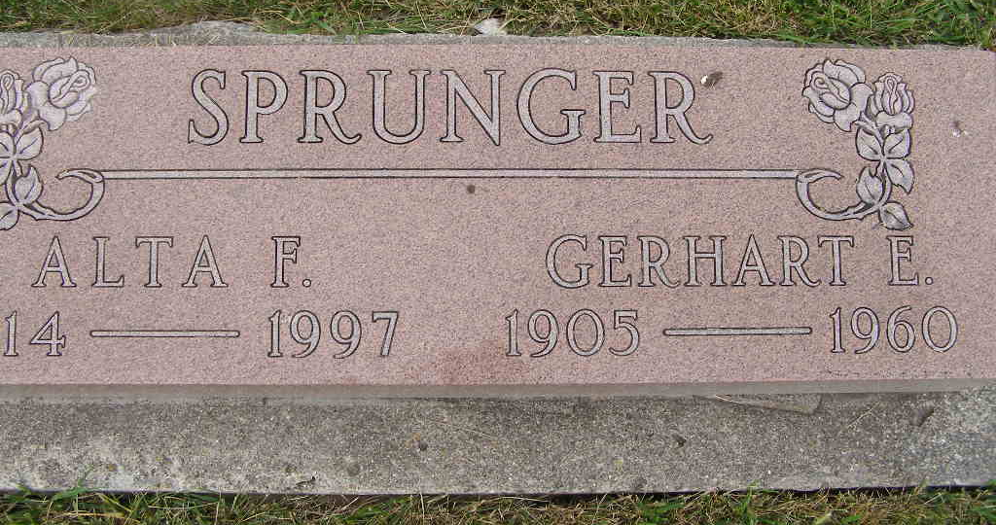
Photo by Shaunda Bedwell Opdycke

Alta F. Sprunger, 83, formerly of Fort Wayne, died Thursday at The Oaks Nursing Home, Columbia City. She was a sales clerk for Patterson-Fletcher. Her husband, Gerhart, died in 1960.
Surviving are a daughter, Cheri Sprunger of Fort Wayne; and a sister, Wilma Bolinger of Columbia City.
Services are 1:30 p.m. Monday at Klaehn, Fahl & Melton Funeral Home, Winchester Road Chapel, 6424 Winchester Road, with calling one hour before services. Calling is also from 2 to 4 and 7 to 9 p.m. Sunday. Burial will be in M.R.E. Cemetery, Berne.
Memorials are to the Alzheimer's Foundation or American Cancer Society.
News-Sentinel, Allen County, Indiana
Friday, September 19, 1997
**
Indiana, U.S., Death Certificates, 1899-2011
Name: Alta Fern Sprunger
[Alta Fern Raber]
Gender: Female
Race: White
Age: 83
Marital status: Widowed
Birth Date: 31 May 1914
Birth Place: Huntington County, IN
Death Date: 18 Sep 1997
Death Place: Columbia City, Whitley, Indiana, USA
Father: Joseph Raber
Mother: Anna Burley
Informant: Cheri Sprunger; daughter; Fort Wayne, Indiana
Burial: September 22, 1997; MRE Cemetery; Berne, Indiana

