Alina Sprunger
July 3, 1893 – June 10, 1968

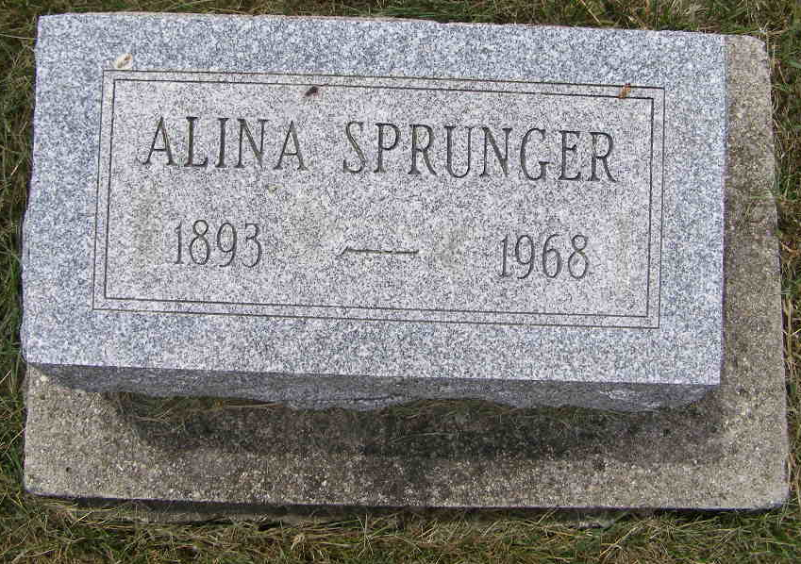
Photo by Shaunda Bedwell Opdycke

Funeral Here Thursday for Alina Sprunger
Local Woman, 74, Dies in Adams County Hospital
Miss Alina Sprunger, 74, a lifelong resident of this community, died at 8:15 pm Monday at the Adams County Memorial Hospital where she had been a patient five weeks. She had been ailing since last October.
Miss Sprunger resided at 506 West Franklin Street. She was employed for 30 years at the former Winner House here. Miss Sprunger was born July 3, 1893, a daughter of Frederick and Katherine Sprunger Sprunger. She was a member of the First Mennonite Church.
Surviving are two sisters, Mrs. John (Bertha) Kauffman, Freeman, South Dakota and Milka Sprunger of 506 West Franklin and who resided with her sister. Three brothers and five sisters preceded in death. They are Daniel, Otto, Ira, Mary Ann, Hannah, Mrs. Gideon (Emma) Sprunger, Mrs. Noah (Dina) Habegger and Rose.
The body is at the Yager Funeral Home where friends may call. Services will be held at the funeral home at 2 pm Thursday Rev. Gordon Neuenschwander and Rev. Gerald Stucky officiating. Burial will be in the MRE Cemetery.
Berne Library Heritage Room, Adams County, Indiana
MRE Obit Book 1966-1972
**
Indiana, U.S., Death Certificates, 1899-2011
Name: Alina Sprunger
Gender: Female
Race: White
Age: 72
Marital status: Never Married (Single)
Birth Date: 3 Jul 1893
Birth Place: Indiana
Death Date: 10 Jun 1968
Death Place: Decatur, Adams, Indiana, USA
Father: Frederick Sprunger
Mother: Katherine Sprunger
Informant: Milka Sprunger; sister; Berne, Indiana
Burial: June 13, 1968; MRE Cemetery; Berne, Indiana

