Alfred Arndt Sprunger
January 17, 1942 – January 18, 1942

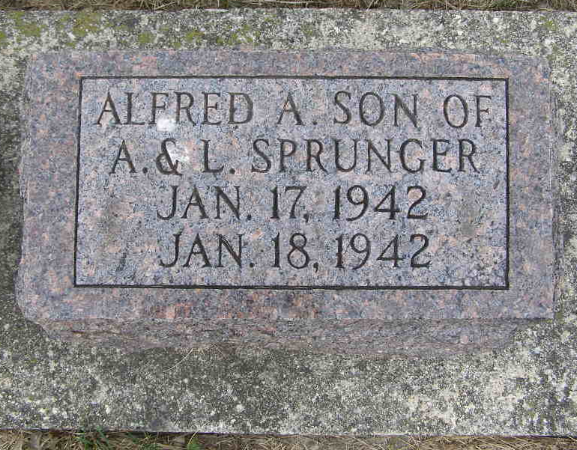
Photo by Shaunda Bedwell Opdycke

Alfred Arndt Springer
in the Indiana, U.S., Death Certificates, 1899-2011
Name: Alfred Arndt Sprunger
Gender: Male
Race: White
Age: 1 day
Birth Date: 17 Jan 1942
Death Date: 18 Jan 1942; premature
Death Place: Fort Wayne, Allen, Indiana, USA
Father: Arther Sprunger
Mother: Leota Suman?
Informant: Arthur Sprunger
Burial: January 18, 1942; MRE Cemetery; Berne, Indiana

