Alfred A. Sprunger
June 7, 1880 – September 10, 1941

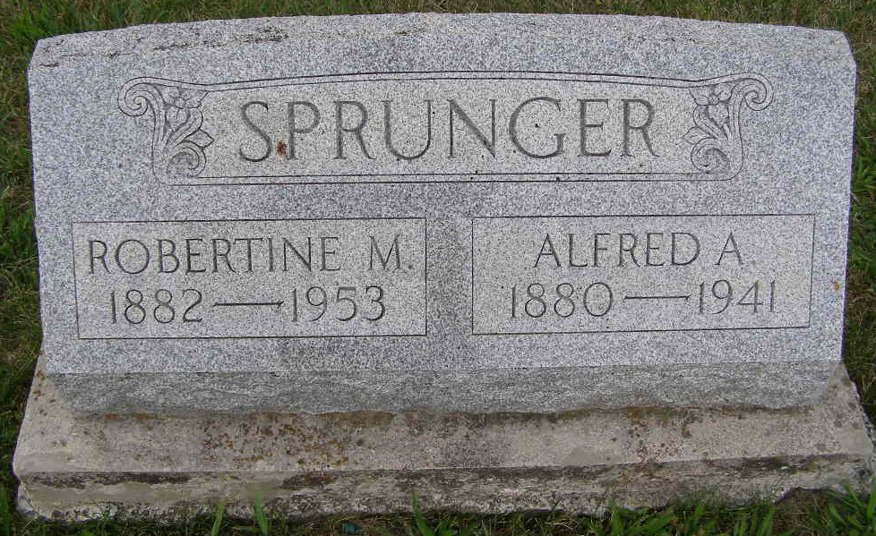
Photo by Shaunda Bedwell Opdycke

ALFRED SPRUNGER FUNERAL WILL BE HELD ON SATURDAY
Life-Long Monroe Township Farmer Dies After Long Illness

Funeral services will be held at 2:00 o’clock Saturday afternoon at the Cross Reformed church her for Alfred Sprunger, 61, prominent Monroe township farmer who died at his home two miles northwest of Berne at 6:00 Wednesday evening, Rev. C. A. Schmid will officiate at the funeral, with Rev. N. J. Schmucher, pastor of the Defenseless Mennonite church assisting. Burial will be in the M. R. E. cemetery. A short service will be held at the residence preceding the church service.
Mr. Sprunger’s death was caused by creeping palsy, according to the attending physician. He had been ailing for about eight years. Mr. Sprunger suffered intense pains at times, but rested fairly well during the last two or three weeks of his illness. He sank into a coma more than a day before he died. He had been bedfast for nearly four years.
Mr. Sprunger spent his entire life on the same farm. He was born on the farm where he died, on June 7, 1880, a son of Abraham A. & Magdalena Neuenschwander Sprunger. On January 1, 1903, he married to Robertine Liechty, who survives.
Surviving are six daughters and three sons, as follows, Mrs. Palmer (Flor-
(continued on Page Two) – not available

Berne Witness, Adams County, Indiana
September 12, 1941

