Aldine Sprunger
December 5, 1881 – December 10, 1881

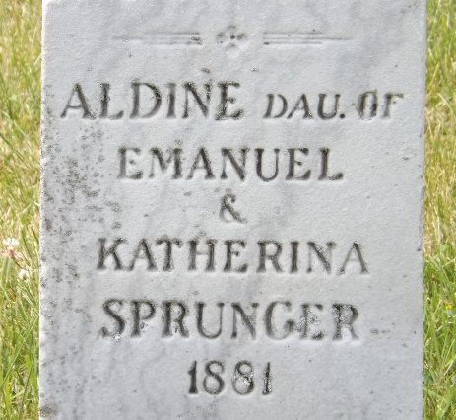
Photo by Jim Allen

U.S., Family History Books
Name Aldina
Birth Date 5 Dec 1881
Father Emanuel Sprunger
Mother Katharina Stauffer
Title The Sprunger Family, 1757-1972: in Three Parts From Manuscripts
p. 62
#26. Emmanuel Sprunger, born November 18, 1854, Adams County, Indiana, married December 6, 1880 to Katharina Stauffer, daughter of Christian Stauffer. They lived n Berne, Indiana. He was a carpenter and a room finisher.
Children:
Aldina b. December 5, 1881
Rufus b. March 19, 1883
Ottilie b. August 23, 1885
Adolph b. August 20, 1887
Zilla b. December 27, 1889

