Adolph Sprunger
August 20, 1887 – June 20, 1951

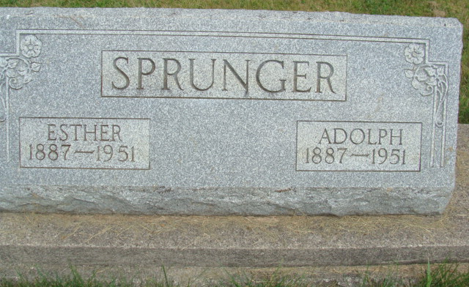
Photo by Alicia Kneuss

Adolph Sprunger
in the Indiana, U.S., Death Certificates, 1899-2011
Name: Adolph Sprunger
Gender: Male
Race: White
Age: 63
Marital status: Widowed
Birth Date: 20 Aug 1887
Birth Place: Monroe Twp, Adams Co, Ind
Death Date: 20 Jun 1951
Death Place: Rural, Adams, Indiana, USA
Father: Emanuel Sprunger
Mother: Katherine Stauffer
Informant: Edward Sprunger; Berne, Indiana
Burial: June 25, 1951; MRE Cemetery; Berne, Indiana

