Adina Sprunger
October 29, 1883 – June 4, 1964

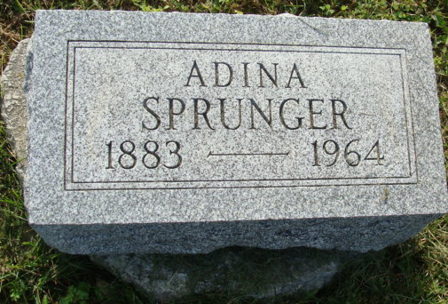
Photo by Alicia Kneuss

Adina Sprunger
in the Indiana, U.S., Death Certificates, 1899-2011
Name: Adina Sprunger
Gender: Female
Race: White
Age: 80
Marital status: Never Married (Single)
Birth Date: 29 Oct 1883
Birth Place: Indiana
Death Date: 4 Jun 1964
Death Place: North Manchester, Wabash, Indiana, USA
Father: Stephen Sprunger
Mother: Anna LIchty
Informant: William Visser; Supt. of Peabody Home; North Manchester, Indiana
Burial: June 8, 1964; MRE Cemetery; Berne, Indiana

