Abraham Sprunger
June 11, 1837 – August 1, 1912

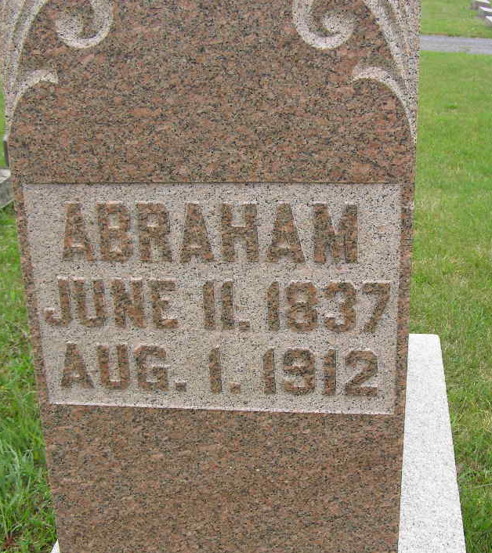
Photo by Shaunda Bedwell Opdycke

Abraham Sprunger was born in Munsterberg, Switzerland. He was married January 11, 1862 to Katharina Moser, daughter of Peter Moser. The couple lived in Adams County, Indiana, where he was a farmer and for many years a cattle dealer. After Katharina's death, he married, on July 3, 1906, Carolina Furrer, daughter of Jacob and Kathryn Gableman Furrer. She was born on January 22, 1880, at Hugsweien, Germany, and came to America in 1902. After Abraham's death she married Amos Sprunger

(Sprunger Book 4.11.7).
**
Abraham Sprunger, living on east Water street, quietly passed away Thursday evening after being in poor health for over two years, old age being the cause. Abraham Sprunger was born on Muensterberg, in Canton Bern, Switzerland, June 18, 1837, came to this country when he was fourteen years old, and lived in French township a number of years, later moving to his present home in Berne. He was married to Catherine Moser Jan. 11, 1862. Twelve children were born to this union, two of whom, Susanna and Noah, have preceded him in death. Those living are Amos in the Klondikes, Abraham better known as "Hamsy", in North Dakota, Eli and Henry of Decatur, and Mrs. Maria, wife of Peter Stauffer, Mrs. Rosina, wife of Jacob B. Steiner, Miss Sarah, Louis, Mrs. Caroline, wife of J. D. Winteregg, Mrs. Aldine, wife of Philip Huser, all of Berne and vicinity. His first companion died in 1901.
In 1906 he was again married to Karolina Furrer, also born in Switzerland and who at the time of her marriage had only been in this country a short time. One little daughter, Della, now five years old, was born to this union.
He leaves beside the family already mentioned a large number of grandchildren, two great-grandchildren, one brother, Rev. S. F. Sprunger, two sisters, Mrs. Christian P. Sprunger and Mrs. Verena Lehman, besides many other relatives.
Funeral was held Sunday at the home and at 9 o'clock at the Mennonite church, where he was a member. The funeral was very largely attended, many having come from neighboring towns and country. "Hamsy" also arrived from North Dakota.
The deceased was known as "Long Abe", this title having been given him when he was actively engaged in the stock buying business of which he made a great success.
Berne Witness, Adams County, Indiana
Tuesday, Aug. 6, 1912
**
Indiana, U.S., Death Certificates, 1899-2011
Name: Abraham Sprnger
Gender: Male
Race: White
Age: 75
Marital status: Married
Birth Date: 11 Jun 1837
Birth Place: Switzerland
Death Date: 1 Aug 1912
Death Place: Berne, Adams, Indiana, USA
Father: Abraham Sprunger
Spouse: Caroline
Informant: Eli Sprunger; Decatur, Indiana
Burial: August 4, 1912; MRE Cemetery

