Sara Magdaline Spichiger
March 16, 1924 – March 17, 1924

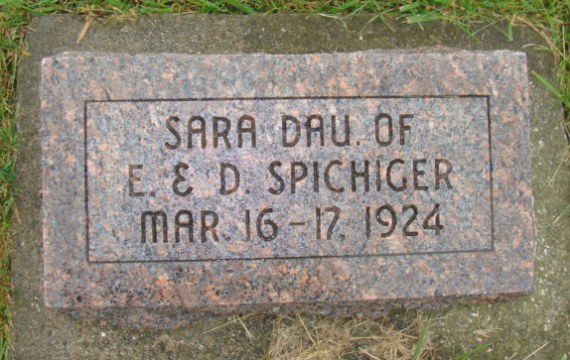
Photo by Alicia Kneuss

The infant child born to Mr. and mrs. Edwin Spichiger of Linn Grove, died late Sunday night after living but a few hours.
The funeral was held Tuesday at the home, after which burial took place at the M. R. E. cemetery

Adams County Witness (IN)
Wednesday, March 19, 1924
**

Indiana, U.S., Death Certificates, 1899-2011
Name: Sarah Magdaline Spichiger
Gender: Female
Race: White
Age: 18 hours
Marital status: Single
Birth Date: 16 Mar 1924
Birth Place: Adams Co Harford Twp Ind
Death Date: 17 Mar 1924; injury in delivery
Death Place: Hartford Twp, Adams, Indiana, USA
Father: Edwin Spichiger
Mother: Dora Beer
Informant: Edwin Spichiger; Linn Grove, Indiana
Burial: March 18, 1924; MRE Cemetery

