Magdalena (Mettler) Spichiger
April 14, 1873 – March 4, 1948

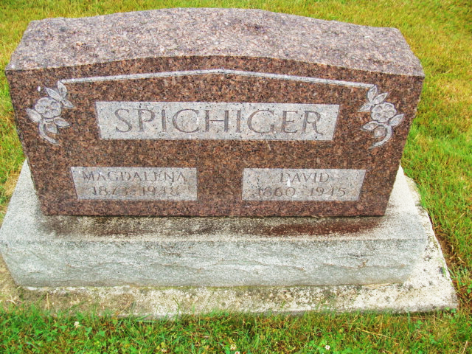
Photo by Alicia Kneuss

WIDOW OF DAVID SPICHIGER DIES HERE THURSDAY
Rites Sunday for Local Woman; Lifelong Resident of Community
Mrs. Magdalena Mettler Spichiger, 74, widow of the late David Spichiger, died at her home on West main Street at 10:55 a.m. Thursday, following an extended illness. Death was caused by carcinoma. She had been ailing for several months and bedfast the past five weeks. Her condition had been critical for some time. A post mortem was performed on the body last evening.
Mrs. Spichiger was a lifelong resident of this community. She was born southwest of Berne, in Wabash Township, April 14, 1873, the daughter of David and Catherine Nussbaum Mettler. She was married to David Spichiger April 16, 1898, in Berne, the vows being received by the late Rev. B. Ruf. He preceded in death December 3, 1945.
The family resided in Hartford Township for many years and is widely known. Mr. and Mrs. Spichiger moved to Berne 12 years ago.
Surviving are the following children; Edwin Spichiger, Linn Grove; Mrs. Tillman (Edna) Lehman, Hartford Township; Mrs. Walter (Wilma) Lehman, near Berne; Mrs. Sylvan (Martha) Habegger, Berne; Mrs. Ralph (Bertha) Miller, Hartford Township; Mrs. Ervin (Helen) Felber, Berne; a foster daughter, Mrs. Ina Chrisman Sheets, wife of Fred Sheets of Angola, who was reared in the Spichiger home from the time she was nine years old and until she became 18; two brothers David and Fred Mettler, both of Berne; a sister, Mrs. Rosa Hofsetter, Geneva, and 30 grandchildren.
In addition to the husband and parents, two sisters, a brother and two grandchildren are deceased.
Mrs. Spichiger was a member of the Cross Evangelical Reformed Church, and an active member of the Dorcas Circle of the church for many years.
The funeral will be held at 2 p.m. Sunday at the church, with the Rev. C. A. Schmid officiating. Burial will be made in the M.R. E. Cemetery. A short service at home will precede the church rites. The body will be returned to the residence this evening from the Yager Mortuary and friends may call at the residence after 7:00 p.m.
Adams County, Indiana Historical Museum
1947Dec-Apr1948 Scrapbook, Image 33
Handwritten-Fri. March 5, 1948

