Dora (Beer) Spichiger
September 25, 1897 – July 19, 1989

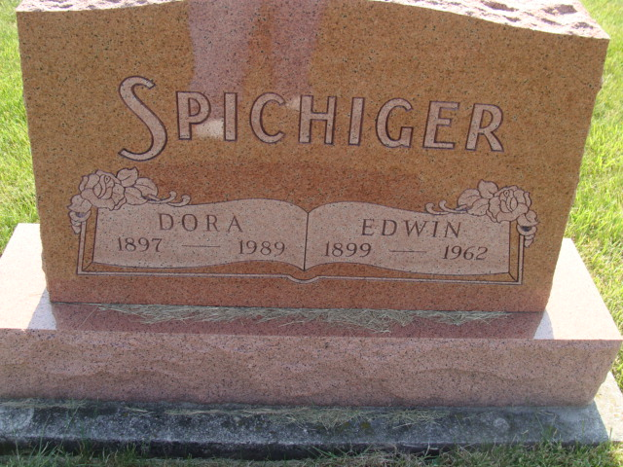
Photo by Alicia Kneuss
Indiana, U.S., Death Certificates, 1899-2017
Name Dora Spichiger
[Dora Beer]
Gender Female
Race White
Marital Status Widowed
Age 91
Birth Date 25 Sep 1898
Birth Place Monroe Twp Adams Colorado
Death Date 19 Jul 1989
Death Place Bluffton, Wells, Indiana, USA
Death Registration Date 1989
Father Christian C Beer
Mother Sarah Ellenberger
Informant Lloyd Spichiger, son
Burial 7/21/1989 M.R.E.

