Abraham Spichiger
April 8, 1862 – March 17, 1933

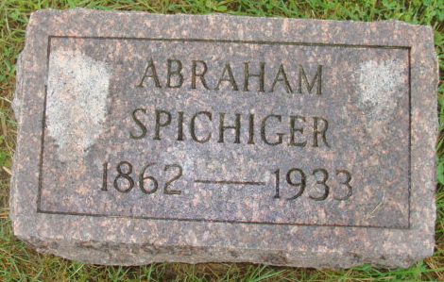
Photo by Alicia Kneuss

Indiana, U.S., Death Certificates, 1899-2017

Name Abraham Spichiger (indexed as Spichiges)
Gender Male
Race White
Marital Status Widowed
Age 70y 11m 9d
Birth Date 8 Apr 1862
Birth Place French
Death Date 17 Mar 1933
Death Place French, Adams, Indiana, USA
Death Registration Date 1933
Father John Spichiger b. Switzerland
Mother Fannie Spichiger b. Switzerland
Informant Dan Spichiger
Burial MRE Cemetery 3/19/1933
**

Indiana, U.S., Marriage Index, 1800-1941

Name A Spichieger
Marriage Date 23 Apr 1889
Marriage Place Adams, Indiana, USA
Spouse Name Emma Urrick

