Virginia Ellen (Habegger) Spencer
June 16, 1931 – January 18, 2008

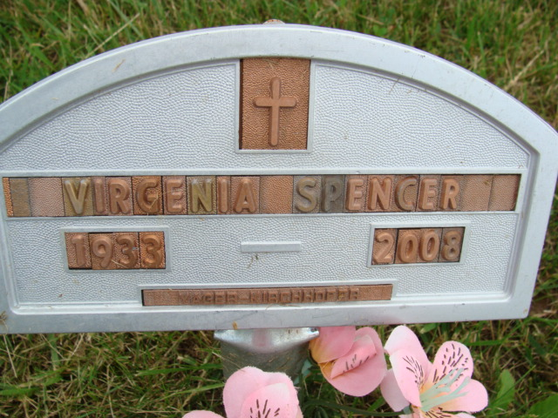
Photo by Alicia Kneuss

U.S., Social Security Death Index, 1935-2014

Name Virginia E. Spencer
Social Security Number xxx
Birth Date 16 Jun 1933
Issue year Before 1951
Issue State Indiana
Last Residence 32244, Jacksonville, Duval, Florida
Death Date 18 Jan 2008
**

Indiana, U.S., Birth Certificates, 1907-1944

Name Virginia Ellen Habegger
Gender Female
Birth Date 16 Jun 1933
Birth Place Monroe, Adams, Indiana, USA
Father Frank Habegger
Mother Selma Nenenschwander
Certificate Number 25082
Roll number 40474_357163
Volume Range 51 - 55

