Joseph Eugene Spencer
June 15, 1931 – May 16, 2010

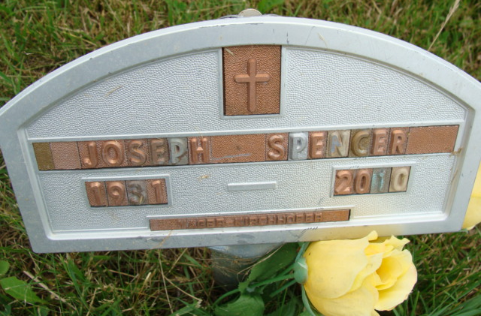
Photo by Alicia Kneuss

U.S., Social Security Death Index, 1935-2014

Name Joseph E. Spencer
Social Security Number xxx
Birth Date 15 Jun 1931
Issue year Before 1951
Issue State Indiana
Last Residence 34287, North Port, Sarasota, Florida, USA
Death Date 16 May 2010
**

Joseph Eugene Spencer from tree Nixon Family Tree

Birth 15 Jun 1931 Fowlerville, Livingston, Michigan, USA
Residence 2006 Jacksonville, Duval, Florida, USA
Death 16 May 2010 North Port, Sarasota, Florida, USA
Father Jacob William Spencer (1901-1975)
Mother Helen Beulah Martin (1903-2005)
Spouse Virginia E. Habegger Spencer (1933-2008)
358 People 16 Records 22 Sources

