William M. Speicher
April 9, 1890 – August 30, 1976

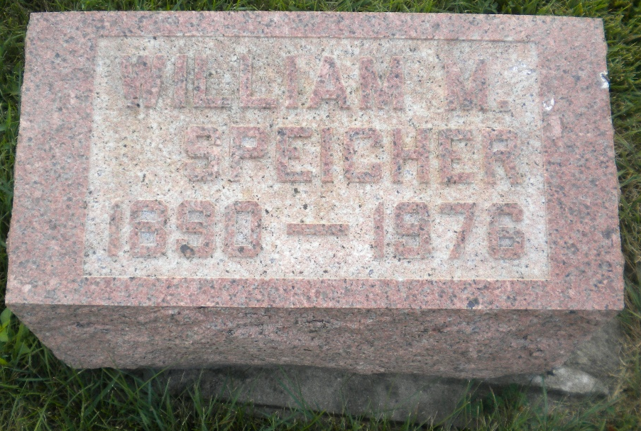
Photo by DSON1492

Indiana, U.S., Death Certificates, 1899-2017

Name William M Speicher
Gender Male
Race White
Marital Status Never Married (Single)
Age 86
Birth Date 9 Apr 1890
Birth Place Indiana
Death Date 30 Aug 1976
Death Place Decatur, Adams, Indiana, USA
Death Registration Date 1976
Father William Speicher
Mother Rosetta Gerber
Informant Dan Speicher, nephew
Burial M.R.E. 9/1/1976

