William Speicher
August 9, 1843 – January 4, 1918

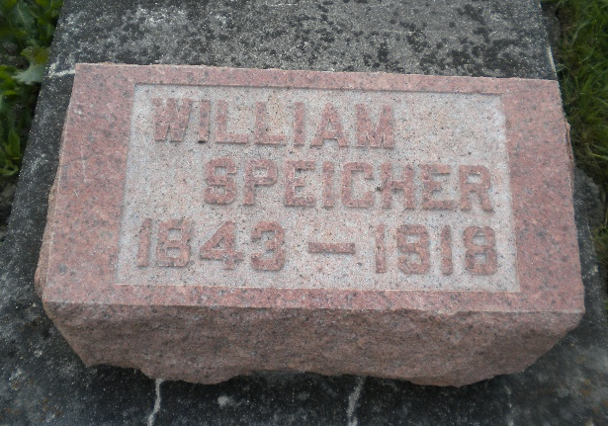
Photo by DSON1492

Indiana, U.S., WPA Death Index, 1882-1920

Name William Speicher
Date Jan 04, 1918
Location Berne
Age 74 Yr
Gender Male
Race White
Source location County Health Office, Decatur
Source notes The source of this record is the book H-13 on page 69 within the series produced by the Indiana Works Progress Administration.
**

Indiana, U.S., Marriage Index, 1800-1941

Name Wm Speicher
Marriage Date 20 Nov 1873
Marriage Place Adams, Indiana, USA
Spouse Name Rosetta Gerber

