Rosetta (Gerber) Speicher
June 27, 1852 – February 2, 1941

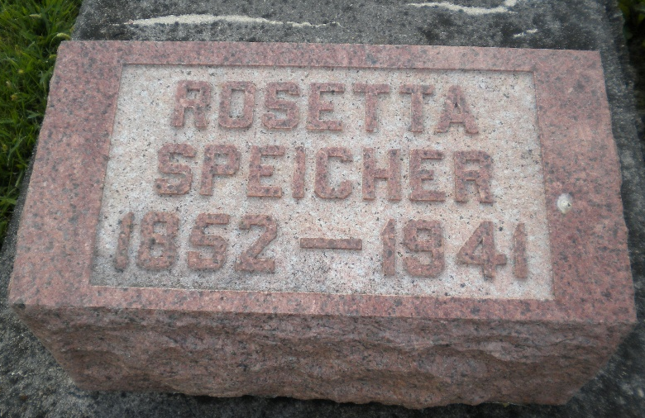
Photo by DSON1492

DEATH CLAIMS MRS. ROSETTA SPEICHER, 88
Funeral for Revered Mother Is Tuesday Afternoon

Mrs. Rosetta Speicher, 88, wife of William Speicher, deceased, died on Sunday at 1:45 a.m. at her home on West Main street. Born in Switzerland on June 27, 1852, as the daughter of Christian and Elizabeth Zmutt Gerber, she has resided in this county almost ever since she came to this country when a year old. She lived in the home, where death occurred, since 1909. Prior to that, she lived on their farm east of Geneva. The decedent had been ailing for the past two years and during the last four weeks, was bedfast and helpless.
Her marriage to William Speicher was an event of November 20, 1873 and to this union were born the following children who survive: Robert at home; Mrs. Martha Stahly of Geneva; Mrs. Ida Meshberger of Geneva, Edwin A. of Geneva; William at home and Mrs. Esther Tonner of Bluffton. Two daughters preceded who are Lavina who died (rest is missing)

Adams County (IN) Historical Museum
1941a Jan-June Scrapbook, image 012
Handwritten-Mon. Feb. 3, 1941
**

Indiana, U.S., Death Certificates, 1899-2017

Name Rosetta Speicher
[Rosetta Gerber]
Gender Female
Race White
Marital Status Widowed
Age 88y 7m 5d
Birth Date 27 Jan 1852
Birth Place Switzerland
Death Date 2 Feb 1941
Death Place Berne, Adams, Indiana, USA
Death Registration Date 1941
Father Christian Gerber b. Switzerland
Mother Elizabeth Zmutt b. Switzerland
Spouse Wm Speicher
Informant Mrs. Martha Stahly
Burial 2-4-1941 M.R.E.

