Robert C. Speicher
September 19, 1874 – October 6, 1960

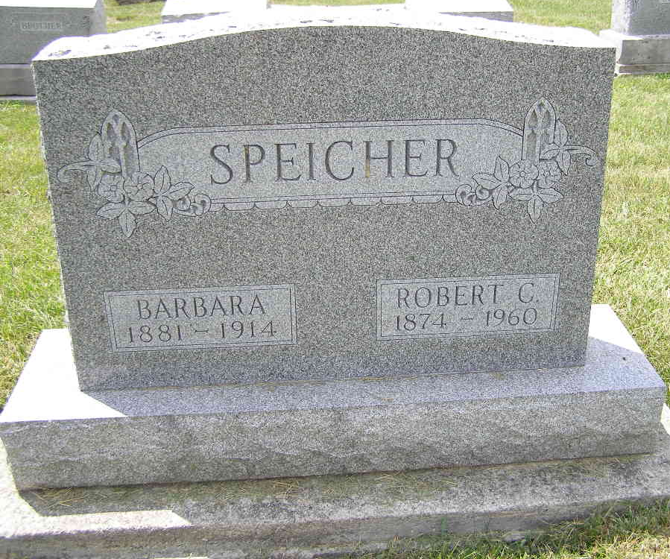
Photo by Shaunda Bedwell Opdycke

Robert C. Speicher Is Taken By Death
Robert C. Speicher, 86, a resident of the Berne community practically his entire life, died Thursday in the Berne Nursing Home following a heart attack. He had been in failing health several weeks.
Mr. Speicher was a member of the Cross United Church of Christ of Berne.
Surviving are two sons, Daniel R. Speicher of Berne, and Paul W. Speicher of Delray Beach, Fla.; two daughters, Mrs. Walter Baumgartner of Schleswig, Ia., and Mrs. David Cooley of Gary; nine grandchildren; a great-grandchild; two brothers, Edwin Speicher of near Geneva, and William Speicher of Berne, and a sister, Mrs. Esther Tonner of Bluffton.
Funeral services will be held at 3 p.m. Sunday in the Cross United Church of Christ, the Rev. C. A. Schmid officiating. Burial will be in the MRE Cemetery. Friends may call at the Yager Funeral Home after 7 p.m. today until 2 p.m. today.
Adams County, Indiana Historical Museum
Jan1958-Dec1960 Scrapbook, Image 53
Handwritten-Fri. Oct. 7, 1960

