Phyllis Marie Speicher
October 26, 1943 -

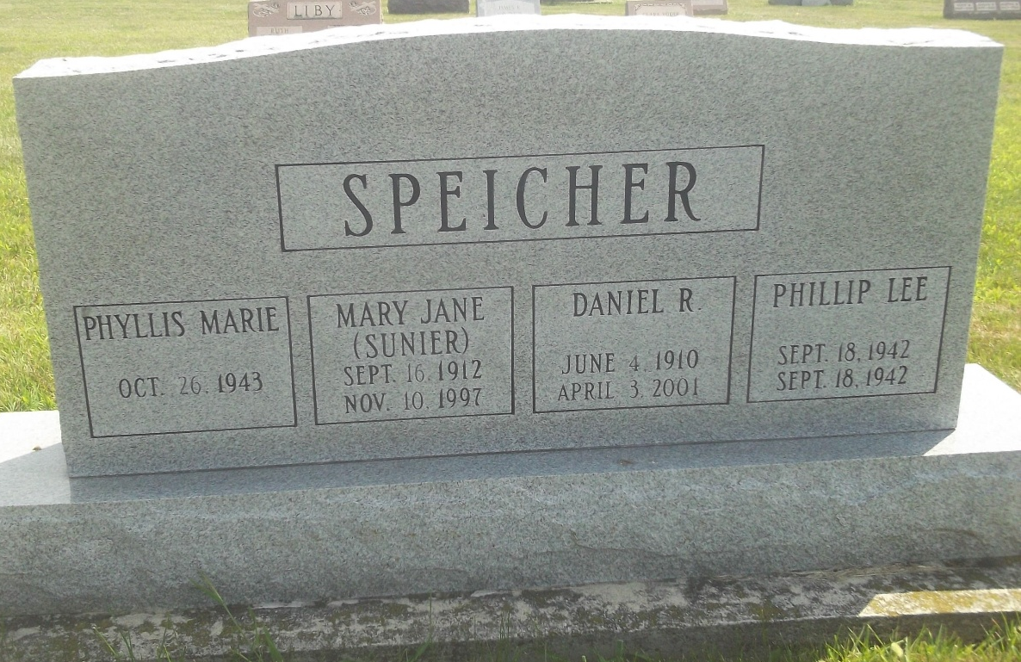
Photo by DSON1492

