Phillip Lee Speicher
September 18, 1942 – September 18, 1942

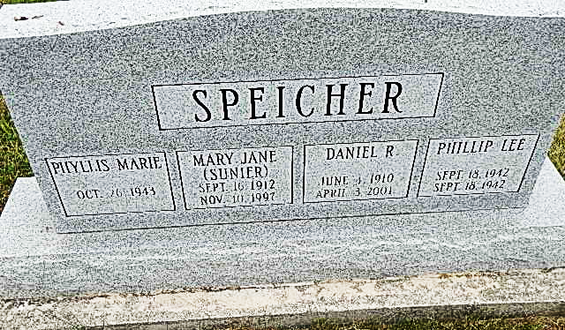
Photo by Alicia Kneuss

Phillip Lee Speicher from tree Haese-Flaherty Family Tree

Birth 18 Sep 1942 Berne, Adams, Indiana, USA
Death 18 Sep 1942 Berne, Adams, Indiana, USA
Father Daniel Robert Speicher (1910-2001)
Mother Mary Jane Sunier (1912-1997)
7000 People 1 Record 13 Sources

