Mary Jane (Sunier) Speicher
September 16, 1912 – November 10, 1997

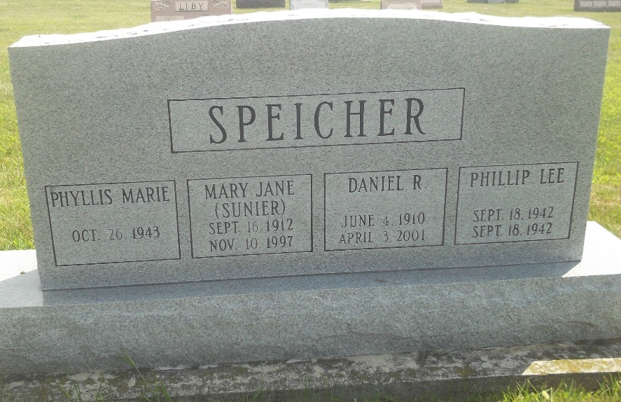
Photo by DSON1492

MARY JANE SPEICHER, 85, died Monday at Adams County Memorial Hospital. She and her husband owned and operated the Moore's Store in Berne for many years.
Surviving are her husband, Daniel; a daughter, Phyllis M. Speicher of Crown Point; a son, Edward W. of Lancaster, Calif.; a sister, Elizabeth "Betty" Moser of Des Allemands, La.; one stepgrandchild; and two stepgreat-grandchildren.
Services at 11 a.m. Friday at Cross United Church of Christ, Berne. Calling from 2 to 5 and 6 to 8 p.m. Thursday and from 8 to 9:30 a.m. Friday at Yager-Kirchhofer Funeral Home, Berne. Calling also an hour before services at the church. Burial in M.R.E. Cemetery, Berne.
Memorials to the church assistance fund.

Journal Gazette, The (Allen County, Indiana)
Wednesday, November 12, 1997

