Martha Rosena Speicher
December 14, 1918 - March 31, 2012

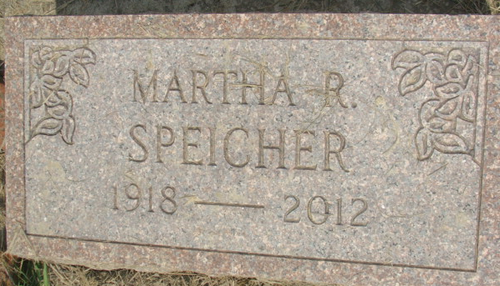
Photo by Alicia Kneuss

Martha R. Speicher, 93, Berne, Ind., died March 31, 2012, at Swiss Village. She was born Dec. 14, 1918, in Adams County, to Edwin and Leah Nyffler Speicher.
Surviving are two nieces, Carolyn (William) Clack, Horseheads, N.Y., and Ruth (Jeff) Gardner, Greenville, S.C., and a nephew, John Speicher, Geyersville, Calif.
Deceased are three siblings, Carl Speicher, Marcus Speicher and Vera Speicher.
She was a member of Cross Community Church and the Dorcas Circle. She retired from Eastern Indiana and Supply Company. She volunteered at Et Cetera Ecke, Berne.
Service is 1 p.m. Tuesday at the church, the Rev. Chris Kruchkow officiating. Burial will follow in MRF Cemetery. Calling is two hours prior to service at the church.
Memorials may be made to the church. Arrangements are being handled by Yager-Kirchhofer Funeral Home.

The Daily Standard, Mercer County, Indiana
Monday, April 2, 2012

