Leah Olga (Nyffeler) Speicher
June 30, 1886 – May 1, 1947

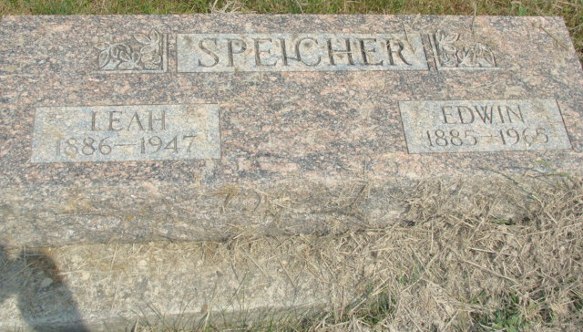
Photo by Alicia Kneuss

2005 Adams County (IN) Death Index
Name Speicher, Leah (Mrs Edwin)
Maiden Nyffeler
Born 6/30/1886
Residence Wabash Twp, Adams, IN
Death 5/1/1947
Place Celina, Mercer, OH
Burial MRE, Wabash Twp, Adams, IN
**

Leah Olga Nyfler from tree Julie's Family Tree

Birth 30 Jun 1886 Indiana, USA
Marriage 23 Oct 1909 Indiana, USA
Residence 1940 Adams, Indiana, USA
Death 1947 Berne, Adams, Indiana, USA
Father Charles Fredrick Nyffeler (1854-1936)
Mother Rosena Rufner (1857-1941)
Spouse Edwin Albert Speicher (1885-1965)
344 People5 Records11 Sources

